Sunday Worship

Scots Church Adelaide

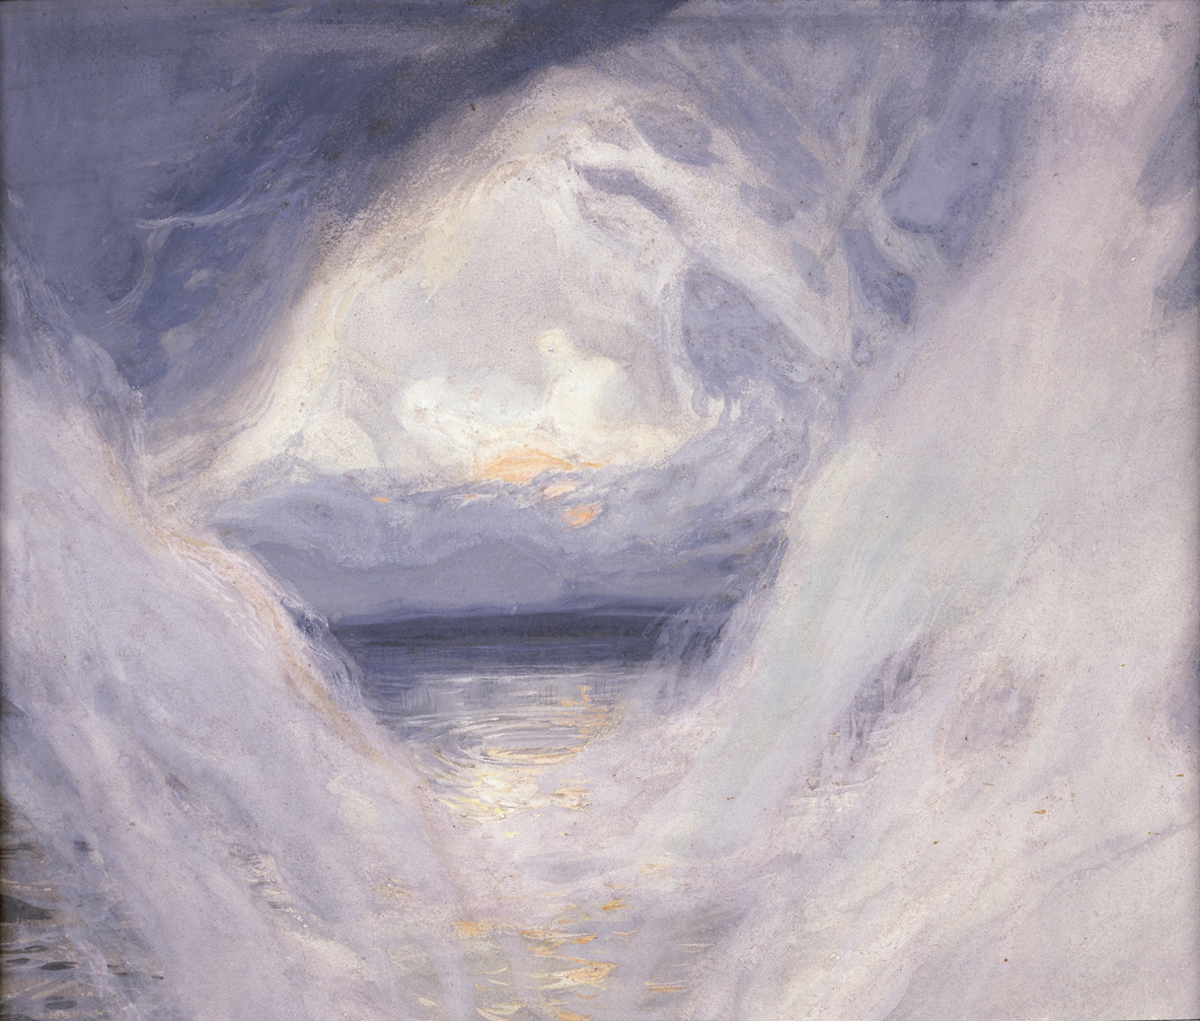

Sunday 13th of September 2026
The Mystical Supper, Russian Orthodox icon, 1497

Scots Church Adelaide is a welcoming,
inclusive, and worshipping community of God,
committed to justice, learning and care,
anticipating a world transformed by the love of God.

Scots Church Adelaide acknowledges that we gather on Kaurna Country, and we pay respect to Elders past, present and emerging. We recognise and respect their culture, beliefs and relationship with the land.

Welcome

An asterisk * indicates that we stand as we are able.
We are invited to speak the words in bold italics.
Helpful instructions and explanations are in italics.
If you require the hearing loop, please sit in the middle of the centre pews.

Meditation

During September, we celebrate the Season of Creation. From the Feast of Creation (6 September) to the Feast of St Francis of Assisi (4 October). Each Sunday between these two feasts, congregations around the world are invited to attend more closely to creation through our prayers and our reading of scripture.

Each week in our meditation, we will contemplate The Creation by James Tissot (1896 – 1902).

When God began to create the heavens and the earth, the earth was complete chaos (Genesis 1:1). Here, the swirling mists of the chaotic world are parting. The sun is rising. Order is being made. The Earth’s first day is dawning.

Each dawn is a new day. We are a new creation (2 Corinthians 5:17). What does the creation of this day bring?

Prelude

The music of the prelude invites us to quieten our busy minds and prepare to worship.

*Processing of the Bible

We stand and together bring the Bible to the centre of our worship service,
expecting to learn and be inspired.

Lighting the Candle

The candle’s flame represents the presence of God with us now and always.

Then God said, “Let there be light,” and there was light.
Light shining in the darkness
The light of creation
The light of the world

(From the Book of Genesis: 10th–5th Century BCE
and the Gospel of John: late 1st century CE)

Call to Worship

We remind ourselves that we are here to worship God together.

The world lives and breathes in God.
We are alive in the mind and heart of God.
The Earth, our home, is a gift to us from God.
We are a sign to each other of God’s love.
We are a sign to each other of God’s faithfulness.
Let us worship!
(Uniting Church in Australia: 21st century CE)

*A Hymn of Praise TIS 391 Come, God's People, sing for joy

Come, God's People, sing for joy
Shout your songs of gladness,
For the hope of Easter day
Overcomes our sadness.
Come with all God's people here,
Who with true affection
Join again to celebrate
Jesus' resurrection.
Years before, as Moses led
Israel's sons and daughters
From their bonds to exodus
through the Red Sea waters:
so the living Lord of life
speaks through our baptism
of the new life which we share
with him who is risen.

That first Easter he arose,
His disciples greeting;
Christians now in every place
Still their Lord are meeting.
Christ, who died for all the world,
In his death brings healing;
And his rising from the grave
Is God's power revealing

Psalm 100

The Hebrew Psalms are an ancient collection of poems long used in Christian worship.

Make a joyful noise to the Lord, all the earth.
Worship the Lord with gladness;

come into God’s presence with singing.
Know that the Lord is God.
It is God who made us,
we are God’s people, and the sheep of God’s pasture.

Enter God’s gates with thanksgiving,
and God’s courts with praise.

Give thanks to God, bless God’s name.
For the Lord is good;
God’s steadfast love endures forever,
and God’s faithfulness to all generations.

(Psalm 100: 10th–5th century BCE)
Prayer

This prayer acknowledges that God is with us and helps us experience God’s presence.

God of creation,
you spoke the first day into life.
Light filled the world, and the Earth lived.

We bring our thanks on this new day
for the earth, our home,
for every green and growing thing,
for every pebble and mountain,
every ocean and river,
for every creature under the heavens.

May we live in the joy of the light of that first day
and of this day.
Amen
(Uniting Church in Australia: 21st century CE)

Prayer of Confession

We are made in the image of God, but so often do not fully live this truth. We do much to damage ourselves and each other. In confession, we acknowledge these hard truths and open ourselves to God’s forgiveness, which comes to us abundantly.

Before God, we confess:

Creator God,
God of the oceans, God of the land and all that is within it:
You created this world with the power of your word.
You formed humankind with your own hands
and breathed your own breath into us.
You gave us these lands as a gift–
a source of our identity and sustenance.
you empowered us to be the stewards of what you have made.

Loving God,
we have failed you and abused the gift you have given us.
We have offended you and defiled what you have made.
Forgive us for betraying your trust.
Forgive us for our greed and arrogance.
Forgive us for what we have done to your earth.
Forgive us for what we have done to your oceans.
Forgive us for what we have done to your creatures,
on the land, in the sky and in the depths.

Hear, O God of Compassion:
The cries of land have become desert;
land laid barren through corrupt agricultural practices,
pollution, mining and deforestation.
The cries of islands drowning in the rising seas,
The cries of distress from Mother Earth.

God of Life,
heal your wounded earth.
Empower us to choose the road that leads to life.
Guide us in the paths of righteousness for your name’s sake
So that we may experience once again your Shalom
in the land and in the sea.
This we ask in the name of the one who came
that we may have life in abundance,
your Son, our Saviour Jesus the Christ.
Amen.
(Rev. James Bhagwan, Fiji: 21st century CE)

Assurance of Pardon and Renewal

Sisters and brothers,
your life is held in God.
God knows where you are weak and where you are strong,
when you have been faithful and when you have failed.
God knows you. God loves you. God forgives you.
Thanks be to God.

*A Hymn of Thanks TIS 462 Now we come our heavenly father.

1. Now we come, our heavenly Father,
one in glad community,
needing still your guiding mercies,
stronger faith, more fervent plea;
all your blessing
now confessing,
we would praise you trustingly.

2. Through the years your Spirit guided
those who blazed the path we tread,
in the glow of faith they laboured,
by the Bread of Life were fed;
while their yearning
hearts were learning
more of Christ, their living head.

WE LISTEN FOR WHAT GOD IS SAYING TO US TODAY

In this part of our worship service, we pray that God might help us understand what we hear,
we listen to parts of the Bible, and a message exploring what those words might mean for us today.

Prayer for Illumination

May these ancient texts be a lamp to our feet
and a light to our path.

(Psalm 119: 10th–5th Century BCE)

An Introduction to the Bible readings

The Psalm for the day

The Psalms express the full range of human emotions before God: joy, sorrow, praise, anger, trust, and repentance. We read the text on the screen in call and response.

Psalm 114
When Israel went out from Egypt, the house of Jacob from a people of strange language,
Judah became God's sanctuary, Israel his dominion.

The sea looked and fled; Jordan turned back.
The mountains skipped like rams, the hills like lambs.

Why is it, O sea, that you flee? O Jordan, that you turn back?
O mountains, that you skip like rams? O hills, like lambs?

Tremble, O earth, at the presence of the LORD, at the presence of the God of Jacob,
who turns the rock into a pool of water, the flint into a spring of water.

The Good News for today

Exodus 14:19-31
¹⁹ The angel of God who was going before the Israelite army moved and went behind them, and the pillar of cloud moved from in front of them and took its place behind them. ²⁰ It came between the army of Egypt and the army of Israel. And so the cloud was there with the darkness, and it lit up the night; one did not come near the other all night.
²¹ Then Moses stretched out his hand over the sea. The Lord drove the sea back by a strong east wind all night and turned the sea into dry land, and the waters were divided. ²² The Israelites went into the sea on dry ground, the waters forming a wall for them on their right and on their left. ²³ The Egyptians pursued and went into the sea after them, all of Pharaoh’s horses, chariots, and chariot drivers. ²⁴ At the morning watch the Lord, in the pillar of fire and cloud, looked down on the Egyptian army and threw the Egyptian army into a panic. ²⁵ He clogged^{[a]} their chariot wheels so that they turned with difficulty. The Egyptians said, “Let us flee from the Israelites, for the Lord is fighting for them against Egypt.”
²⁶ Then the Lord said to Moses, “Stretch out your hand over the sea, so that the water may come back upon the Egyptians, upon their chariots and chariot drivers.” ²⁷ So Moses stretched out his hand over the sea, and at dawn the sea returned to its normal depth. As the Egyptians fled before it, the Lord tossed the Egyptians into the sea. ²⁸ The waters returned and covered the chariots and the chariot drivers, the entire army of Pharaoh that had followed them into the sea; not one of them remained. ²⁹ But the Israelites walked on dry ground through the sea, the waters forming a wall for them on their right and on their left.
³⁰ Thus the Lord saved Israel that day from the Egyptians, and Israel saw the Egyptians dead on the seashore. ³¹ Israel saw the great work that the Lord did against the Egyptians. So the people feared the Lord and believed in the Lord and in his servant Moses.

Matthew 18:21-35
²¹ Then Peter came and said to him, “Lord, if my brother or sister sins against me, how often should I forgive? As many as seven times?” ²² Jesus said to him, “Not seven times, but, I tell you, seventy-seven^{[a]} times.
²³ “For this reason the kingdom of heaven may be compared to a king who wished to settle accounts with his slaves. ²⁴ When he began the reckoning, one who owed him ten thousand talents was brought to him, ²⁵ and, as he could not pay, the lord ordered him to be sold, together with his wife and children and all his possessions and payment to be made. ²⁶ So the slave fell on his knees before him, saying, ‘Have patience with me, and I will pay you everything.’ ²⁷ And out of pity for him, the lord of that slave released him and forgave him the debt. ²⁸ But that same slave, as he went out, came upon one of his fellow slaves who owed him a hundred denarii, and seizing him by the throat he said, ‘Pay what you owe.’ ²⁹ Then his fellow slave fell down and pleaded with him, ‘Have patience with me, and I will pay you.’ ³⁰ But he refused; then he went and threw him into prison until he would pay the debt. ³¹ When his fellow slaves saw what had happened, they were greatly distressed, and they went and reported to their lord all that had taken place. ³² Then his lord summoned him and said to him, ‘You wicked slave! I forgave you all that debt because you pleaded with me. ³³ Should you not have had mercy on your fellow slave, as I had mercy on you?’ ³⁴ And in anger his lord handed him over to be tortured until he would pay his entire debt. ³⁵ So my heavenly Father will also do to every one of you, if you do not forgive your brother or sister from your heart.”

In sacred words of old,
we have heard the Spirit speak anew.

Sermon

Reflection:

A moment, aided by music, to reflect on what we have heard and said in our worship together.

WE RESPOND IN FAITH

In this part of our worship service, we commit ourselves to live out the message of love that we have heard.

*A Hymn of Dedication When we walk with the Lord

When We Walk With The Lord (Trust And Obey)
When we walk with the Lord
In the light of His Word
What a glory He sheds on our way
While we do His good will
He abides with us still
And with all who will trust and obey
Trust and obey
For there's no other way
To be happy in Jesus
But to trust and obey

Not a shadow can rise
Not a cloud in the skies
But His smile quickly drives it away
Not a doubt nor a fear
Not a sigh nor a tear
Can abide while we trust and obey
refrain

Not a burden we bear
Not a sorrow we share
But our toil He doth richly repay
Not a grief nor a loss
Not a frown nor a cross
But is blessed if we trust and obey
Refrain

But we never can prove
The delights of His love
Until all on the altar we lay
For the favor He shows
And the joy He bestows
Are for those who will trust and obey
refrain

Then in fellowship sweet
We will sit at His feet
Or we'll walk by His side in the way
What He says we will do
Where He sends we will go
Never fear only trust and obey
Refrain

Prayers of the People

We pray for our world, and we pray the prayer that Jesus taught to his disciples.

Let us pray:

For peace in our world,
peace for the broken-hearted,
peace for the despairing.
Let us pray to the Lord

[SILENCE]

For peace in our world,
for peace in our land,
for peace in our homes,
Let us pray to the Lord

[SILENCE]

Peace for those who have died,
peace for those who mourn,
peace for the lonely and lost.
Let us pray to the Lord

[SILENCE]

For peace in our minds,
for peace in our hearts,
for peace in our souls.
Let us pray to the Lord

[SILENCE]

For forgiveness,
generosity and love
among all people everywhere,
and for the coming kingdom of peace,
We pray to the Lord.
Amen.

(Anglican Book of Common Prayer: early 20th century CE)

The Lord’s Prayer

Let us pray:

Our Father in Heaven
hallowed be your name,
your kingdom come,
your will be done,
on earth as in heaven.
Give us today our daily bread.
Forgive us our sins,
as we forgive those who sin against us.
Save us from the time of trial
and deliver us from evil.
For the kingdom, the power, and the glory
are yours, now and forever. Amen.

(Matthew 6:9-13: 1st century CE)
Invitation to the Offering

One practical way of responding to God’s love is to contribute money to help others in need.

We are, each of us, the gift of God in the world.
Let us give of ourselves in joy.

Our offering will now be received.

*Prayer of Dedication

We bring our offerings to God and pray that they might be used wisely.

God of goodness and mercy,
we thank you that you invite us to participate
in the work of mercy and the building of justice.
May all that we give, money, time, energy
be gift in the world.
Amen.

*A Hymn of Commissioning TIS 665 Jesus Christ is waiting

Jesus Christ is waiting,
waiting in the streets;
no-one is his neighbour,
all alone he eats.
Listen, Lord Jesus,
I am lonely too.
Make me, friend or stranger,
fit to wait on you
Jesus Christ is raging,
raging in the streets,
where injustice spirals
and real hope retreats.
Listen, Lord Jesus,
I am angry too.
in the Kingdom’s causes
let me rage with you.
Jesus Christ is healing,
healing in the streets;
curing those who suffer,
touching those he greets.
Listen, Lord Jesus,
I have pity too.
let my care be active,
healing just like you.

LIFE AND MINISTRY OF OUR COMMUNITY

We share news about our life together in community.

WE GO IN FAITH

Our worship together now moves from this service and this place out into our hours and our days.

We continue to make community amongst us by hearing the Blessing, passing the peace and moving to the hall to share tea, coffee, and conversation.

If you are visiting with us, we invite you to join us this morning.
If you need to go, we understand.

You may wish to sign our visitors’ book as you leave.

*Affirmation

An affirmation expresses things we believe are true. We speak it aloud
to remind ourselves of our calling and to embed it in our lives.

We believe
that every human being is made in the image and likeness of God
and possesses a dignity and value which can never be taken away.

We believe
that as children of the one God
we are one family with mutual responsibility for each other

(Cardinal Basil Hume: late 20th century CE)

*Passing the Peace

We send each other out into our day in peace.

Peace be with you. And also with you

*Blessing

The Blessing reassures us that God is with us.

Go forth into the world in peace;
be of good courage;
hold fast that which is good;
render to no one evil for evil;
strengthen the faint-hearted;
support the weak;
help the afflicted;
honour all people;
love and serve the Lord,
rejoicing in the power of the Holy Spirit.
Amen.
(St. Chrysostom, The Anglican Book of Common Prayer: 20th century CE)

Choral Amen TiS 783 (ii)

*Processing the Bible
Please remain standing as you are able for the processing of the Bible.

Postlude
Before we go, we invite you to sit in contemplation as we hear the Postlude.

Sources used in worship today as noted through worship booklet.
Music reproduced with permission licenses #604419-A, OneLicense,
and #496838&#352810, CCLI. Images. The Creation by James Tissot (1896 – 1902).

Scots Online

If you are visiting with us today, you might like to access our services online on the worship page of our website: scotschurch.org

You can also find Paul’s blog on the Bible passages used in the sermon at: sundaybible.substack.com

About Scots Church Adelaide

Scots Church Adelaide began in 1851, formed by local supporters of the Free Church, a reform movement in the Church of Scotland that opposed political control of the church and engaged with the social changes of the 1800s, including industrialisation and urbanisation.

The church was originally named after the leader of the movement, Thomas Chalmers.

In 1865, Chalmers Free Church joined congregations of the Church of Scotland, the United Presbyterians, and the Free Church to form the Presbyterian Church of South Australia.

In 1929, the Chalmers congregation amalgamated with the Presbyterian congregation in Flinders St and took the name Scots Church Adelaide. After the church building in Flinders St was demolished, items including the organ, windows and plaques were installed in Scots Church, and the Flinders St stonework was re-used as facing for our office block.

In 1977, most of the Presbyterian Church of Australia joined with the Methodist Church of Australasia and the Congregational Church of Australia to form the Uniting Church in Australia. So, Scots Church Adelaide became a Uniting Church congregation.

Over the years, the congregation has supported many social initiatives. Today, Scots continues its commitment to the city community as a neighbour and place open to all. We host community organisations, including the SA Jazz Archive and The Big Issue. Our facilities are available for use by other community groups.

The building is the second oldest church still standing in the city. The current ministers are Rev Paul Turley, Minister of the Congregation, and Rev Jill Lienert, Minister for Community Connections. Worship services are held at 10.30am each Sunday.



SCOTS CHURCH ADELAIDE
Uniting Church in Australia
Kaurna Country 237 North Terrace, Adelaide
Ministers: Rev Paul Turley, Rev Jill Lienert
Phone 8223 1505 www.scotschurch.org
 www.facebook.com/scotschurchadelaide

