Sunday Worship

Scots Church Adelaide

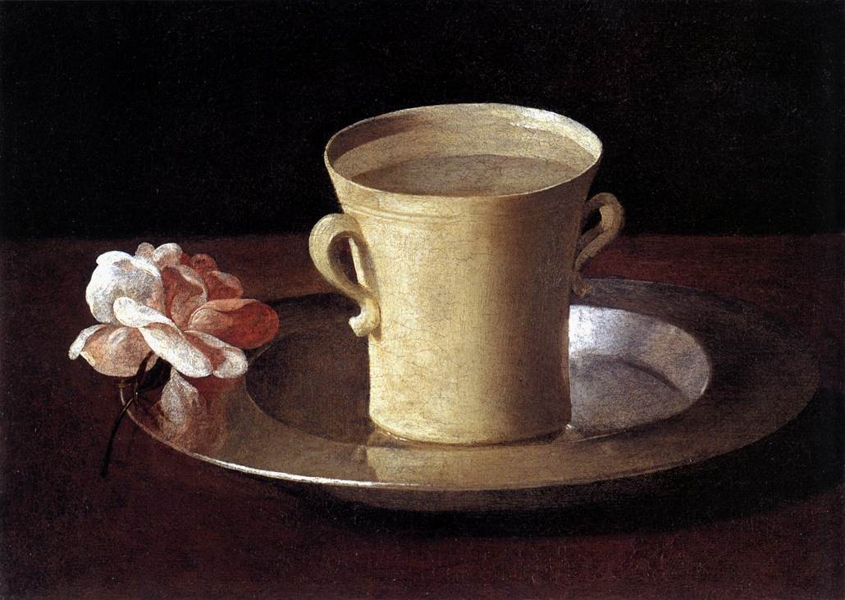

Sunday 28th June 2026

Scots Church Adelaide is a welcoming,
inclusive, and worshipping community of God,
committed to justice, learning and care,
anticipating a world transformed by the love of God.

Scots Church Adelaide acknowledges that we gather on Kaurna Country, and we pay respect to Elders past, present and emerging. We recognise and respect their culture, beliefs and relationship with the land.

Welcome

An asterisk * indicates that we stand as we are able.
We are invited to speak the words in bold italics.
Helpful instructions and explanations are in italics.
If you require the hearing loop, please sit in the middle of the centre pews.

Meditation

Francisco de Zubaran, like most Spanish painters of his time, painted religious paintings. While A Cup of Water and a Rose, 1630, might not look particularly religious to us, to Zubaran’s seventeenth-century audience, both items represented the Virgin Mary. Saint Bernard of Clairvaux, in the twelfth century, called Mary the Mystic Rose. The simple cup and the water represented Mary’s purity and humility. And it is a cup of cold water that Jesus speaks of at the end of instructing his disciples in our text for today. After all the joys and all of the warnings in the instructions, Jesus reminds them and us of the simple human necessity that we all have for the gift of a cup of cold water.

Prelude

The music of the prelude invites us to quieten our busy minds and prepare to worship.

*Processing of the Bible

We stand and together bring the Bible to the centre of our worship service,
expecting to learn and be inspired.

Lighting the Candle

The candle’s flame represents the presence of God with us now and always.
Then God said, “Let there be light,” and there was light.
Light shining in the darkness

The light of creation
The light of the world

(from the Book of Genesis: 10th–5th century BCE
and the Gospel of John: late 1st century CE)
Call to Worship

We remind ourselves that we are here to worship God together.

The world belongs to God,
the earth and all its people.

How good it is, how wonderful
to live together in unity.

Love and faith come together;
justice and peace join hands.

God’s breath is in our lungs
God’s light fills our eyes

This is God’s new day
Let us rejoice and be glad in it!

(from the Iona Community: late 20th century CE)

*A Hymn of Praise 137 For the beauty of the earth

1. For the beauty of the earth,
for the beauty of the skies,
for the love which from our birth
over and around us lies,
Christ, our God, to you we raise
this our sacrifice of praise.

2. For the beauty of each hour
of the day and of the night,
hill and vale, and tree and flower,
sun and moon and stars of light,
Christ, our God, to you we raise
this our sacrifice of praise.
3. For the joy of ear and eye,
for the heart and mind's delight,
for the mystic harmony
linking sense to sound and sight.
4. For the joy of human love,
brother, sister, parent, child,
friends on earth and friends above,
for all gentle thoughts and mild.
5. For each perfect gift divine
to our race so freely given,
graces all of your design,
flowers of earth and buds of heaven,
6. For the church that evermore
lifting holy hands above,
offers up on every shore
the pure sacrifice of love,

Psalm 100

The Hebrew Psalms are an ancient collection of poems long used in Christian worship.

Make a joyful noise to the Lord, all the earth.
Worship the Lord with gladness;

come into God’s presence with singing.
Know that the Lord is God.
It is God who made us,
we are God’s people, and the sheep of God’s pasture.

Enter God’s gates with thanksgiving,
and God’s courts with praise.

Give thanks to God, bless God’s name.
For the Lord is good;
God’s steadfast love endures forever,
and God’s faithfulness to all generations.

(Psalm 100: 10th–5th century BCE)

Prayer

This prayer acknowledges that God is with us and helps us experience God’s presence.

Almighty God,
to whom all hearts are open,
all desires known,
and from whom no secrets are hidden:
cleanse the thoughts of our hearts
by the inspiration of your Holy Spirit,
that we may perfectly love you,
and worthily magnify your holy name;
through Christ our Lord.
Amen.
(Anglican Book of Common Prayer: 10th century CE)

Prayer of Confession

We are made in the image of God, but so often do not fully live this truth. We do much to damage ourselves and each other. In confession, we acknowledge these hard truths and open ourselves to God’s forgiveness, which comes to us abundantly.
Before God, we confess:

God of all love and care,
we confess that we have sinned against you
in thought, word, and deed:
we have not loved you with our whole heart,
we have not loved our neighbour as ourselves,
we have not cherished the earth.
We turn to you, seeking forgiveness.
Remind us that we are children of your love.
Amen.

(Uniting Church in Australia: 21st century CE)

Assurance of Pardon and Renewal

This saying is sure and worthy of full acceptance,
That Christ Jesus came into the world to save sinners.
We are forgiven and made whole.
Thanks be to God.
(1 Timothy 1:15: 1st century CE)

*A Hymn of Thanks 442 All praise to our redeeming Lord

1 All praise to our redeeming Lord,
who joins us by his grace,
and bids us, each to each restored,
together seek his face.

2 He bids us build each other up;
and gathered into one,
to our high calling's glorious hope
we hand in hand go on.

3 The gift which he on one bestows
we all delight to prove;
the grace through every vessel flows,
in purest streams of love.
4 Even now we think and speak the same,
and cordially agree;
concentred all, through Jesus' name,
in perfect harmony.

5 We all partake the joy of one,
the common peace we feel,
a peace to sensual minds unknown,
a joy unspeakable.

6 And if our fellowship below
in Jesus be so sweet,
what heights of rapture shall we know
when round his throne we meet.

WE LISTEN FOR WHAT GOD IS SAYING TO US TODAY

In this part of our worship service, we pray that God might help us understand what we hear,
we listen to parts of the Bible, and a message exploring what those words might mean for us today.

Prayer for Illumination

May these ancient texts be a lamp to our feet
and a light to our path.
(Psalm 119: 10th–5th Century BCE)

An Introduction to the Bible readings

The Psalm for the day

The Psalms express the full range of human emotions before God: joy, sorrow, praise, anger, trust, and repentance. We read the text on the screen in call and response.
Psalm 89:1–4, 15–18

I will sing of your steadfast love, O LORD, for ever;
with my mouth I will proclaim your faithfulness to all generations.

For I declare that your steadfast love is established for ever;
your faithfulness is as firm as the heavens.

You said, ‘I have made a covenant with my chosen one,
I have sworn to David my servant:

“I will establish your descendants for ever,
and build your throne for all generations.”’

Happy are the people who know the festal shout,
who walk, O LORD, in the light of your countenance,

who exult in your name all day long,
and extol your righteousness.

For you are the glory of their strength;
by your favour our horn is exalted.

For our shield belongs to the LORD,
our king to the Holy One of Israel.

The Good News for today

Genesis 18:1-19
18 The Lord appeared to Abraham by the oaks of Mamre, as he sat at the entrance of his tent in the heat of the day. ² He looked up and saw three men standing near him. When he saw them, he ran from the tent entrance to meet them and bowed down to the ground. ³ He said, “My lord, if I find favor with you, do not pass by your servant. ⁴ Let a little water be brought, and wash your feet, and rest yourselves under the tree. ⁵ Let me bring a little bread, that you may refresh yourselves, and after that you may pass on—since you have come to your servant.” So they said, “Do as you have said.” ⁶ And Abraham hastened into the tent to Sarah and said, “Make ready quickly three measures of choice flour, knead it, and make cakes.” ⁷ Abraham ran to the herd and took a calf, tender and good, and gave it to the servant, who hastened to prepare it. ⁸ Then he took curds and milk and the calf that he had prepared and set it before them, and he stood by them under the tree while they ate.
⁹ They said to him, “Where is your wife Sarah?” And he said, “There, in the tent.” ¹⁰ Then one said, “I will surely return to you in due season, and your wife Sarah shall have a son.” And Sarah was listening at the tent entrance behind him. ¹¹ Now Abraham and Sarah were old, advanced in age; it had ceased to be with Sarah after the manner of women. ¹² So Sarah laughed to herself, saying, “After I have grown old, and my husband is old, shall I be fruitful?” ¹³ The Lord said to Abraham, “Why did Sarah laugh and say, ‘Shall I indeed bear a child, now that I am old?’ ¹⁴ Is anything too wonderful for the Lord? At the set time I will return to you, in due season, and Sarah shall have a son.” ¹⁵ But Sarah denied, saying, “I did not laugh,” for she was afraid. He said, “Yes, you did laugh.”
¹⁶ Then the men set out from there, and they looked toward Sodom, and Abraham went with them to set them on their way. ¹⁷ The Lord said, “Shall I hide from Abraham what I am about to do, ¹⁸ seeing that Abraham shall become a great and mighty nation, and all the nations of the earth shall be blessed in him? ¹⁹ No, for I have chosen him, that he may charge his children and his household after him to keep the way of the Lord by doing righteousness and justice, so that the Lord may bring about for Abraham what he has promised him.”

Matthew 10:40-42
⁴⁰ “Whoever welcomes you welcomes me, and whoever welcomes me welcomes the one who sent me. ⁴¹ Whoever welcomes a prophet in the name of a prophet will receive a prophet’s reward, and whoever welcomes a righteous person in the name of a righteous person will receive the reward of the righteous, ⁴² and whoever gives even a cup of cold water to one of these little ones in the name of a disciple—truly I tell you, none of these will lose their reward.”
In sacred words of old,
we have heard the Spirit speak anew.

Sermon

Reflection:

A moment, aided by music, to reflect on what we have heard and said in our worship together.

WE RESPOND IN FAITH

In this part of our worship service, we commit ourselves to live out the message of love that we have heard.

*A Hymn of Dedication 572 O thou who camest from above

1. O Thou who camest from above,
the pure celestial fire to impart,
kindle a flame of sacred love
on the mean altar of my heart.

2. There let it for thy glory burn
with inextinguishable blaze,
and trembling to its source return,
in humble prayer and fervent praise.

3. Jesus, confirm my heart's desire
to work, and speak, and think for thee;
still let me guard the holy fire,
and still stir up thy gift in me.

4. Ready for all thy perfect will,
my acts of faith and love repeat,
till death thy endless mercies seal,
and make my sacrifice complete.
Prayers of the People

We pray for our world, and we pray the prayer that Jesus taught to his disciples.

Let us pray:

Remember, O Lord,
All the people of the earth.
Made in your image, children of earth, children of God.

Remember, O Lord,
the widow, the orphan, the poor, the sick, the weary, the stranger, the traveller; all who are under persecution, captivity, or in exile.
Be yourself their helper, protector, and defender.

Remember, O Lord,
every soul in affliction and distress, needing your mercy and help.

Remember, O Lord,
all leaders and civil authorities. Grant them peaceful governance, that in their tranquillity we may lead quiet and godly lives.

Remember, O Lord,
your church which is from one end of the world to the other.
Strengthen this holy house until the end of the world.

Remember, O Lord,
those who love us and those who hate us,
those who have asked us to pray for them,
and those whom we have forgotten because of our human weakness.

Remember, O Lord,
your good earth, with all its wonders, home to all creatures.

Remember, O Lord,
all who have died. Grant them rest in the place of light,
where there is no sickness, sorrow, or sighing.

Make us all worthy of your kingdom,
through the grace and love of your Son,
with whom you are blessed, together with your all-holy, good, and life-giving Spirit, now and always and unto the ages of ages.
Amen.

(The Liturgy of St. James: 4th century CE)

The Lord’s Prayer

Let us pray:

Our Father in Heaven
hallowed be your name,
your kingdom come,
your will be done,
on earth as in heaven.
Give us today our daily bread.
Forgive us our sins,
as we forgive those who sin against us.
Save us from the time of trial
and deliver us from evil.
For the kingdom, the power, and the glory
are yours, now and forever. Amen.

(Matthew 6:9-13: 1st century CE)

Invitation to the Offering

One practical way of responding to God’s love is to contribute money to help others in need.

We are, each of us, the gift of God in the world.
Let us give of ourselves in joy.

Our offering will now be received.
*Prayer of Dedication

We bring our offerings to God and pray that they might be used wisely.

God of great compassion,
may what we give here be hope in the world.
May we each be gifts of love in the world.
Amen.

*A Hymn of Commissioning 626 Lord of creation, to you be all praise!

1 Lord of creation, to you be all praise!
Most mighty your working, most wondrous your ways!
Your glory and might are beyond us to tell,
and yet in the heart of the humble you dwell.

2 Lord of all power, I give you my will,
in joyful obedience your tasks to fulfill.
Your bondage is freedom; your service is song;
and, held in your keeping, my weakness is strong.

3 Lord of all wisdom, I give you my mind:
rich truth that surpasses our knowledge to find,
what eye has not seen and what ear has not heard
is taught by your Spirit and shines from your word.

4 Lord of all bounty, I give you my heart;
I praise and adore you for all you impart,
your love to inspire me, your counsel to guide,
your presence to shield me, whatever betide.

5 Lord of all being, I give you my all;
if ever I leave you I stumble and fall;
but, led in your service your word to obey,
I’ll walk in your freedom to the end of the way.

LIFE AND MINISTRY OF OUR COMMUNITY

We share news about our life together in community.

WE GO IN FAITH

Our worship together now moves from this service and this place out into our hours and our days.

We continue to make community amongst us by hearing the Blessing, passing the peace and moving to the hall to share tea, coffee, and conversation.

If you are visiting with us, we invite you to join us this morning.
If you need to go, we understand.

You may wish to sign our visitors’ book as you leave.

*Affirmation

An affirmation expresses things we believe are true. We speak it aloud
to remind ourselves of our calling and to embed it in our lives.

We believe
that every human being is made in the image and likeness of God
and possesses a dignity and value which can never be taken away.

We believe
that as children of the one God
we are one family with mutual responsibility for each other

(Cardinal Basil Hume: late 20th century CE)

*Passing the Peace

We send each other out into our day in peace.
Peace be with you. And also with you

*Blessing

The Blessing reassures us that God is with us.

Go forth into the world in peace;
be of good courage;
hold fast that which is good;
render to no one evil for evil;
strengthen the faint-hearted;
support the weak;
help the afflicted;
honour all people;
love and serve the Lord,
rejoicing in the power of the Holy Spirit.
Amen.
(St. Chrysostom, The Anglican Book of Common Prayer: 20th century CE)

Choral Amen TiS 783 (ii)

*Processing the Bible
Please remain standing as you are able for the processing of the Bible.

Postlude
Before we go, we invite you to sit in contemplation as we hear the Postlude

Sources used in worship today as noted through worship booklet.
Music reproduced with permission licenses #604419-A, OneLicense,
and #496838&#352810, CCLI. Image: Francisco de Zubaran, A Cup of Water and a Rose, 1630.

About Scots Church Adelaide

Scots Church Adelaide began in 1851, formed by local supporters of the Free Church, a reform movement in the Church of Scotland that opposed political control of the church and engaged with the social changes of the 1800s, including industrialisation and urbanisation.

The church was originally named after the leader of the movement, Thomas Chalmers.

In 1865, Chalmers Free Church joined congregations of the Church of Scotland, the United Presbyterians, and the Free Church to form the Presbyterian Church of South Australia.

In 1929, the Chalmers congregation amalgamated with the Presbyterian congregation in Flinders St and took the name Scots Church Adelaide. After the church building in Flinders St was demolished, items including the organ, windows and plaques were installed in Scots Church, and the Flinders St stonework was re-used as facing for our office block.

In 1977, most of the Presbyterian Church of Australia joined with the Methodist Church of Australasia and the Congregational Church of Australia to form the Uniting Church in Australia. So, Scots Church Adelaide became a Uniting Church congregation.

Over the years, the congregation has supported many social initiatives. Today, Scots continues its commitment to the city community as a neighbour and place open to all. We host community organisations, including the SA Jazz Archive and The Big Issue. Our facilities are available for use by other community groups.

The building is the second oldest church still standing in the city. The current ministers are Rev Paul Turley, Minister of the Congregation, and Rev Jill Lienert, Minister for Community Connections. Worship services are held at 10.30am each Sunday.



SCOTS CHURCH ADELAIDE
Uniting Church in Australia
Kaurna Country 237 North Terrace, Adelaide
Ministers: Rev Paul Turley, Rev Jill Lienert
Phone 8223 1505 www.scotschurch.org
 www.facebook.com/scotschurchadelaide

